Guided Capstone Project Report

Big Mountain Resort is looking to increase their ticket price by adding additional features to their resort. They wanted to find which of their scenarios would produce the most value. We compared Big Mountain to resorts across the U.S. and compiled an assortment of features; ranging from snowfall per year, to ski lifts per user.

Our first task was creating a model that would properly weigh each feature and the relationship it had with ticket price. We used the Random Forest Model to weigh each item depending on their significance of changing price.

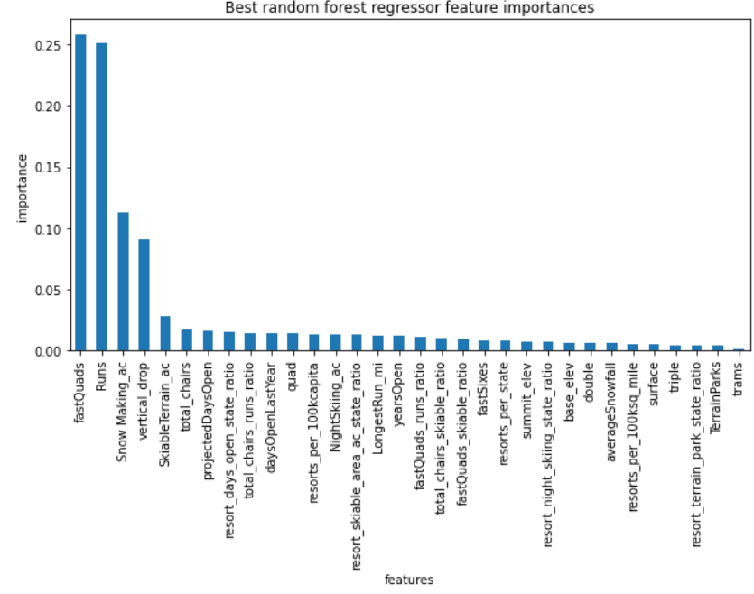

Our next step was to model the data. We removed Big Mountain from our test group so that we would have no overfitting issues and used our model to predict Big Mountain’s prices. From our findings we saw that Big Mountain Resort had a modelled price of $95.87, when their actual price was $81. Once we have the weighed amount for each item we can begin looking at the changes that Big Mountain Resort wanted to make.

The first scenario would be to close runs to cut costs while keeping the price the same, from our test we saw an initial decrease after removing 3 runs but leveled until 5 runs where it saw another significant decrease. Scenario two, we would add a run and increase the vertical drop by 150 feet while installing an additional chair lift. Our model predicted that this would allow us to increase price by $1.99 and over the course of the season bring in $3,474,638. Our third scenario is the same as scenario two but included the addition of 2 acres worth of snowmakers, which provided no additional price increase according to our model. The last scenario was to increase the longest run by .2 miles and add 4 acres worth of snowmakers. This scenario proved to add no value to the price as our model does not weigh length of slops heavily.

From our analysis we conclude that scenario two is the best option as it brings in over $3 million in additional income while the ski lift cost for the year would only be $1 million.